Lesson Plan: Jing for Finance!

By: Joy Hopkins
Course: CEP 800 - Learning in School and Other Settings
Date: March 24, 2013

TABLE OF CONTENTS
About 3
Diagram 1: The TPCK Framework^{1/} 3
Content 3
Pedagogy 4
Content & Pedagogy 4
Technology 4
Technology & Pedagogy 4
Technology & Content 5
Assessment 5

About
The purpose of this document is to outline a lesson plan to teach a group of eight finance professionals how to use Jing, a screenshot and screencast software, to create robust desktop manuals and training materials. The lesson plan was designed using the Technological Pedagogical Content Knowledge (TPCK) framework made popular by Michigan State University’s Punya Mishra and Matt Koehler. The TPCK framework, illustrated in Diagram 1 below, challenges educators to consider three primary forms of knowledge: Technology, Pedagogy, and Content knowledge when teaching with technology.

Diagram 1: The TPCK Framework^{1/}
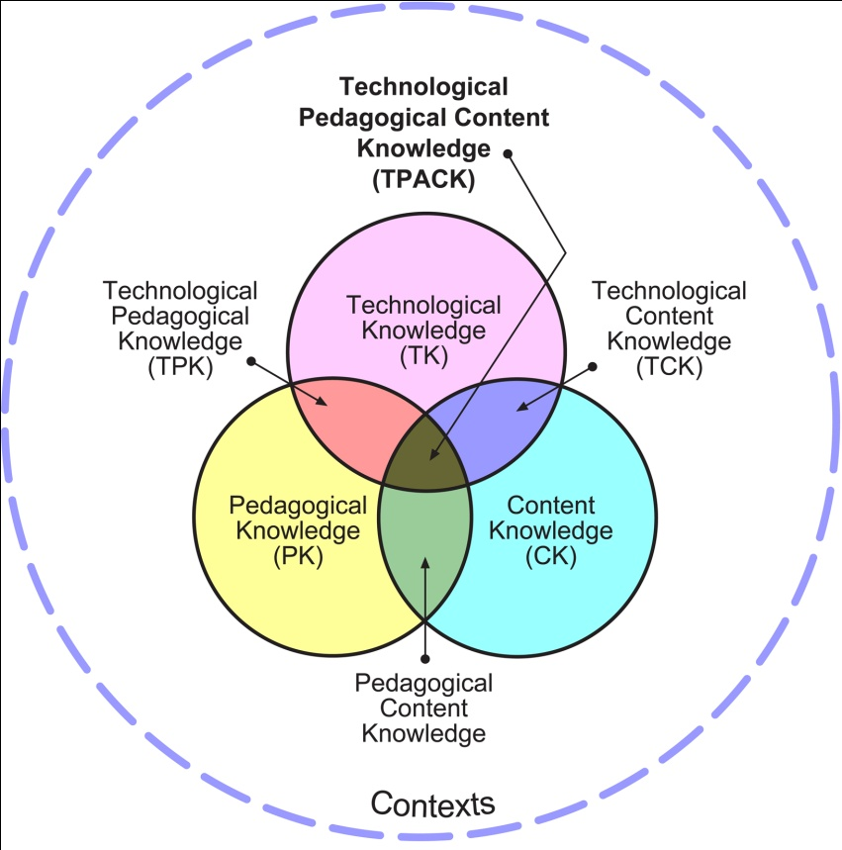
^{1/} Reproduced by permission of the publisher, © 2012-2013 by tpack.org.

Content
The lesson content includes (1) the procedures for how to use Jing, a screenshot and screencast software, to make desktop manuals and training materials more robust and (2) ideas on how to use the tool effectively to improve business processes within the 8-member finance team.
Since the technology will be new to the finance analysts, the most challenging concepts may be how to take advantage of all the benefits the software has to offer. This includes creating and sharing screenshots (still shots with annotations) and screencasts (video tutorials).

Pedagogy
To best teach this content, I will adopt a constructivist approach. The analysts will learn by doing. Analysts will each be required to create at least one training document complete with annotated screenshots and illustrative screencasts. The reason why this approach will be taken is because the very goal of the lesson is for the analysts to be able to create content using Jing on an ongoing basis. To this end, it is crucial that the analysts get comfortable with using the tools in ways that make sense to each of them individually.
In terms of learner characteristics, some members of the team are not native English speakers. However, all team members are fluent in English. Nonetheless, extra care will be taken to not overcomplicate language used in instruction.

Content & Pedagogy
The hands-on, constructivist approach helps teach the content in a way that will be meaningful to each of the eight analysts. This approach was chosen over other approaches, because it allows students to be actively engaged in the content at their own pace. The goal is not for the analysts to memorize all the functions that Jing has to offer, but to understand which ones they can use to better document the business processes that they, and they alone, own.
Fortunately, there are no technical constraints with this approach as each analyst has access to a computer and can download the Jing software for free. The only physical constraint is that three of the eight analysts are located outside of the US in time zones such that it would be difficult for the whole team to meet at the same time.

Technology
The greatest feature of this lesson plan is that the technology that will be taught will play a central role in actually teaching the lesson itself. What better way to teach something than with the actual technology itself? This use of technology is not absolutely necessary to achieve the lesson’s objectives, but it makes the most sense. I could, for example, simply print out instructions for the analysts, but that would be ironic given the very goal of the lesson is to create more robust training materials using the technology itself. The fact that my own training materials for the lesson on Jing would not include screenshots and screencasts would send the wrong message.

Technology & Pedagogy
The Jing software fits in well with the pedagogical strategy and constructivist theories about learning. Jing is all about making it easier to share knowledge by capturing exactly what is that you have on your screen via screenshots and screencasts. This technology lends itself well to tutorials and training documents, which the finance analysts will be creating.

Technology & Content
In this case, we could not have a closer match between the technology and the content, as they are one in the same. The technology, Jing, is also the content that is being taught.
That said, the Jing technology itself has a help function that will help the analysts as they create the content they wish to add to their own training materials. I believe the help function will aid in the student’s learning of three of the main goals of the lesson, including:
- How do I capture an image of my screen and edit it (add highlights, notes, arrows)?
- How do I capture video to create narrated tutorials using my computer screen?
- How do I share content (screenshots and screencasts) via IM, email, and other social media?

This is a nice resource for the analysts to have as they each explore the tool at their own pace.

Assessment
The lesson’s success will be measured by the ability of each analyst to answer the following four essential questions:
- What are some effective ways we can use Jing to improve the productivity of our finance team?
- How do I capture an image of my screen and edit it (add highlights, notes, arrows)?
- How do I capture video to create narrated tutorials using my computer screen?
- How do I share content (screenshots and screencasts) via IM, email, and other social media?
The analysts will be able to demonstrate their understanding of the above by creating at least one desktop manual or training document that integrates Jing screenshots and screencasts. We will also have a brainstorming session to address effective ways Jing can be used to improve productivity of our finance team. Minutes will be taken in the brainstorming session to document the ideas for future reference. The training documents and minutes from our lesson will be saved on a central shared drive, which all analysts can access at any time.

